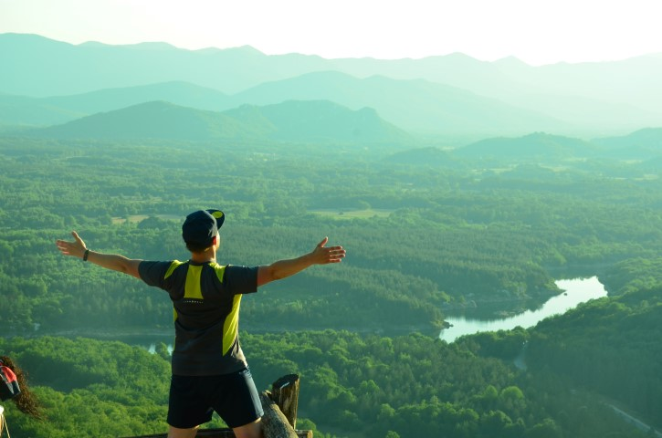

***Stories of Nature – learn how to conserve nature***

**COUNTRY:** **Croatia**

**TOWN:** **Perušić, Lika – Senj county**

**START DATE FOR THE VOLUNTEERS: 20.8.2018.**

**END DATE FOR THE VOLUNTEERS:** **17.9.2018.**

**TOTAL DURATION INCLUDING TRAVEL:** **29 days**

**AGE GROUP:** **between 18 and 30 years**

**COUNTRIES PARTICIPATING: Greece (5 volunteers), Portugal (2 volunteers), Spain (8 volunteers)**

**GENERAL INFO:**

The project is taking place in small town called Perušić, situated in the middle of Croatia in a mountain region called Lika. The municipality of Perušić is small region inhabited by approximately 2500 people. „Petitt“ but lovely, place is situated on very good geographical location. You need less than two hours with a car to visit some of the most interesting touristic locations such as capital of Croatia Zagreb, city of Zadar interesting with its Roman city core, stunning National Park Plitvice's lakes, National Park Northern Velebit and beautiful coast of Adriatic sea which is in this summer period full of life.

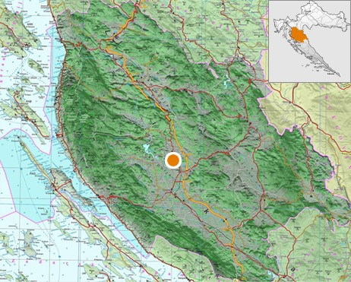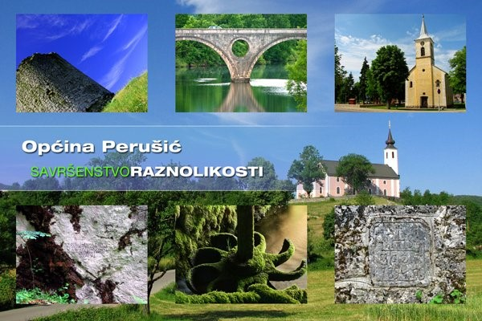

**THINGS TO EXPECT UPON ARRIVAL:**

The partner organization will take care of a volunteer trip from their cities to Croatia (Zagreb), and a host organization (Public institution) for volunteers transport from the airport to bus station Zagreb and Zagreb to Perušić. Upon arrival in Perušić, the volunteers will meet a supervisor, two mentors at the bus station/train station who will take them to the place of residence. Perušić is a place with rich past, landscapes of intact nature, a place where people still live in the warm and good-neighborly surrounding. It is a place with a small number of people who are almost all familiar with each other so the place did not take contours of global, alienated and hurried life. In Perušić, there are several shops with mixed products such as Konzum, several cafes, restaurants and pizzeria, sports grounds, National Library etc. In the case of volunteer injury in Perušić, there is an ambulance for emergency cases, and 15 km further in Gospić is General Hospital. Volunteers will be located in two-family houses in the park area (village Jurišići) 2km from the center of Perušić, the office of the PI and the entrance to the park. Family houses are decorated in a traditional style with a yard and a garden. Each house, except the room, also has a kitchen, living room and bathroom. Volunteers will prepare their own food on the basis of monthly food support. The PI will provide volunteers with bicycles. In the case of field work (field research etc.) together with park employees, they will travel with official cars. Volunteers will be familiar with other transport options, primarily buses and timetables for the buses if volunteers want to go to nearby Gospić and so on.

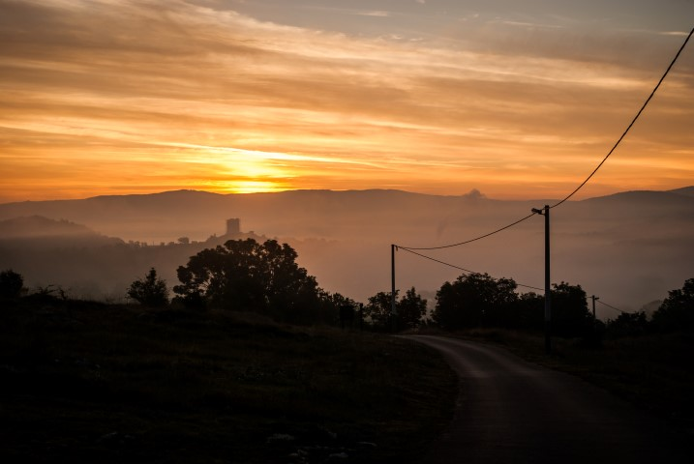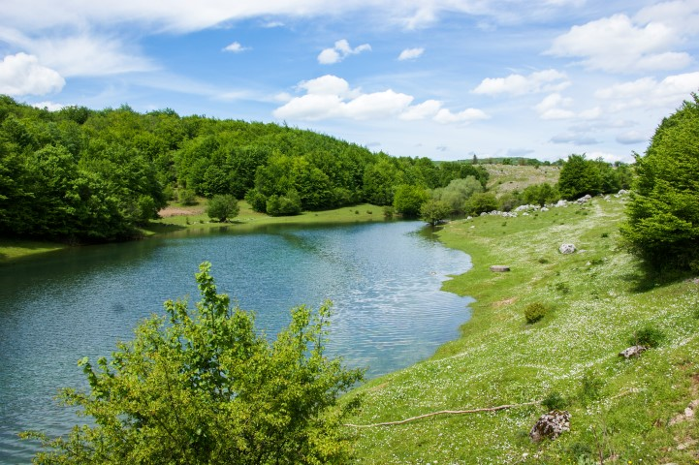

**GENERAL OBJECTIVE OF THE STORIES OF NATURE PROJECT:**

The overall goal of the project Stories of Nature is to enable young people from different environments (ethnic, cultural, religious) to acquire knowledge and experience in the field of climate change, environmental protection and sustainable tourism. In order to achieve the general goal, three specific aims have been set:

* *To enable volunteers to acquire new skills (communication, organizational and administrative) and knowledge through learning in teamwork and the development of social and ecological awareness*
* *Improve the quality of work of the PI through the integration of new working methods into day-to-day activities, creating a modern and dynamic working environment and European cooperation*
* *All volunteer activities and their voluntary work should be made visible on the local, national and international level. In order to achieve the above objectives and to make it easier to understand, the project is divided into two components:*

🡪 Involving the volunteers in the arrangement of trails and educational trails; inclusion the volunteers in protection (exploration of bats and karst areas); inclusion in planning (using GPS) and marking new trails in the park area; work on restoring of touristic infrastructure in the park area; inclusion of the volunteers in the process of creating a new touristic zones / park attractions (from planning, concrete work to promotion); engaging in marketing through project brochures and climate change flyers.

🡪 Educational component: preparation and holding of Croatian language course for volunteers, participation in workshops and sharing experiences on karst / water in karst / environmental protection / Natura 2000 / environmental laws and their application to the reality and life of each of us; climate change - time is now. Also, volunteers will have opportunity to visit the cave Samograd and Medina cave (theme: speleology bases); The old town of Perušić (theme: cultural heritage of the Lika region); rafting on the river Lika (theme: water in karst); Visit the Fruit Center (theme: local economy); HKUD Perušić, Gargaše Association (theme: Ethnographic Heritage), Budina cave (adventurous speleology).

**What the volunteers get through this project?**

By implementing the project the volunteers will be fully acquainted with the life of man in the karst area, will have the opportunity to learn what karst is, how does man (or do not) influence on this sensitive ecosystem, how he as an individual can contribute to the preservation of the sensitive karst system, and preserve it for future generations. As the Lika-Senj County is the greenest county in Croatia with many Natura 2000 sites, it will also be possible, through a collaboration of field experts, to find out the benefits of Natura 2000 conservation and why they are important. Volunteers will have the ability to master the basic marketing tools and will be directed to all the opportunities of rural development, so it is expected that they will actually be the ambassadors of nature and its beauties that need to be preserved but also visited. Also, they will be ambassadors of their country as they will have an opportunity to present their country during the project activities through stories about culture, history, tradition, lifestyle, youth life in countries from which volunteers are. As the Stories of Nature project actually represents Croatia, the Croatian language will be the one to promote through daily volunteer courses and it is expected that after the month of learning it, volunteers will be able to stand alone on the basics of Croatian language. By implementing the project volunteers will gain work experience, improve communication skills, improve teamwork skills, and get the opportunity to become independent and become self-motivated and ultimately to make their personal goals. It is expected that the project will stimulate volunteers to pro-ecological thinking, but also will be enabled to understand more about Croatian culture, history, lifestyles and opportunities provided here.

